Chemistry 102 Name __________________
Exam 3a Spring 2017

Page 2 (36 points)

Page 3 (18 points)

Page 4 (22 points)

Page 5 (18 points)

Page 6 (10 points)

Total (104 points)

Multiple Choice
- London dispersion forces attractions between molecules depends on what two factors?
- Molar mass and shape | - Vapor pressure and size
- Molar mass and volatility | - Volatility and shape

- Which of the following statements about intermolecular forces is true?
- London dispersions forces are the strongest of the three types.
- They occur within molecules rather than between the molecules.
- Hydrogen bonding occurs between any two molecules that contain hydrogen atoms.
- Dipole-dipole interactions occurs between two polar molecules

- Which pair of solute and solvent would be miscible?
- H₂O and Hg | - C₃H₈ and C₂H₅OH | - Br₂ and PF₃
- NH₃ and CH₃OH | - none of the above

- As the temperature of a gas sample increases, the number of molecules and volume remaining constant, the pressure exerted by the gas
- Decreases | - Increases
- Remains the same | - Unable to determine

- The compound formed from the condensation reaction between a glycerol molecule and 3 fatty acid molecules contains the following functional group.
- Alcohol | - Ether | - carboxylic acid
- aldehyde | - Ester

- Which of the following is considered a colloid
- 0.9% NaCl | - 5% glucose | - mayonnaise
- vinegar (5% acetic acid) | - muddy water

- Given that the solubility of sodium acetate is 76 grams per 100 grams of water. What is unsaturated?
- 90 g of sodium acetate dissolved in 100 g of water | - 450 g of sodium acetate dissolved in 500 g of water
- 240 g of sodium acetate dissolved in 300 g of water | - 100 g of sodium acetate dissolved in 200 g of water
- all of them

- A water solution of acetic acid, vinegar, 'barely lights a light bulb (low conductivity). This means that vinegar is a(n):
- weak electrolyte | - strong electrolyte
- non-electrolyte | - semi-electrolyte

- The rubbing alcohol sold in drug stores often is composed of 70% isopropyl alcohol and 30% water. In this solution (based on the percentages)
- Isopropyl alcohol is the solvent | - Water is the solvent
- Both water and isopropyl alcohol are solvents. | - Neither water nor isopropyl alcohol is a solvent.

- What kind of taste do carboxylic acids have?
- sweet | - sour | - fruity
- slippery | - salty

- If the pH of an aqueous solution increases the molar concentration of _____
- Hydronium decreases | - Hydroxide ion decreases
- Hydronium increases | - There is no change in the hydronium hydroxide concentration

- How does soap clean dirt away from clothes?
- The nonpolar head group interacts with water
- The polar head group interacts with water
- The polar tails form a micelle and the dirt sticks to the outside nonpolar heads
- The nonpolar tails form a micelle that interacts with dirt
- I and III | - IV only | - I, II and III | - II and IV | - none of these

- Why corn oil is a liquid and lard is a solid?
- The oil has no double bonds and thus has more intermolecular forces
- The oil has cis double bonds that make kinks and thus there are less intermolecular forces
- The oil has trans double bonds and they are toxic
- The fats are colder and thus have more intermolecular forces
- None of these

- Which of the following statements is correct?
- As pressure increases, the amount of gas dissolved in a liquid increases
- As temperature increases, the amount of gas dissolved in a liquid increases
- As temperature decreases, the amount of gas dissolved in a liquid increases
- As pressure decreases, the amount of gas dissolved in a liquid increases
- I and III | - II and IV | - I, II and III | - IV only | - none of these

- Which of the following combinations make a buffer solution?
- HCl and KCl | - H₂CO₃ and Na₂CO₃
- H₃PO₄ and NaCl | - HC₂H₃O₂ and KC₂H₃O₂

- Which of the following acids, if in solutions of equal concentration, is the least acidic?
a) Phenol, K_{a} = 1.3 x 10⁻¹⁰ b) Lactic acid, K_{a} = 1.4 x 10⁻⁴
c) Saccharin, K_{a} = 2.1 x 10⁻¹² d) Boric acid, K_{a} = 5.8 x 10⁻¹⁰
e) All of these acids are equally acidic because they are all of equal concentration.

- The movement of substances from an area of high concentration to an area of low concentration by interacting with a carrier molecule is an example of
- Osmosis. | - Active transport. | - Facilitated diffusion.
- Diffusion | - Filtration.

- Which of the following is a strong acid?
- HClO₄ | - H₃PO₄ | - HF
- H₂CO₃ | - All are weak acids

Short Answer

- (6 points) Given the following compounds CH₄ or CH₃F at 20ºC
  - Determine all intermolecular forces in each

CH₃F:__dipole-dipole, London dispersion_________

CH₄:__ London dispersion __________________________________________________

  - Which has the higher vapor pressure at a given temperature. Explain your prediction
The weaker the intermolecular forces, the weaker the interactions that hold the substance together, the higher the vapor pressure of a liquid at the given temperature, and the easier it is to vaporize a substance. Since CH₄ has the weakest intermolecular forces it will have the highest vapor pressure

- (6 points) Rank the following from highest to lowest boiling point (1 is highest 5 is lowest)
CH₃OCH₂CH₃ | CH₃CH(OH)CH₃ | (CH₃)₂CHCH₃ | CH₃CH₂CH₂CH₃ | CH₃CH₂CH₂CH₂CH₃
2 | 1 | 5 | 4 | 3

b) If any can hydrogen bond to themselves draw two molecules and illustrate the Hydrogen bonding
- (6 points) Label each beaker solution as isotonic, hypertonic, or hypotonic and draw an arrow to show the direction of water movement by osmosis.

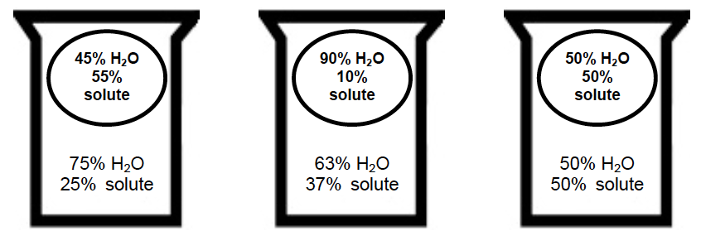

__ hypotonic __ ___ hypertonic ___ _____ isotonic _______

- (10 points) For each reaction below: (1) identify each reaction below as an Arrhenius acid-base reaction, a Brønsted-Lowry acid-base reaction, or both; (2) indicate the acid and conjugate acid if present and the base and conjugate base if present in each reaction.

- C₅H₅N _{(aq)} | + H₂O _{(l)} | C₅H₅NH⁺ _{(aq)} | + OH⁻ _{(aq)} | (circle) Arrhenius, Brønsted-Lowry, or both
Base | Acid | Conjugate acid | Conjugate base

- 2 KOH_{(aq)} | + H₂SO_{4 (aq)} | 2 H₂O _{(l)} | + K₂SO_{4 (aq)} | (circle) Arrhenius, Brønsted-Lowry, or both
Base | Acid | Conjugate acid | Conjugate base

- (8 points) A solution is prepared by dissolving 8.975 grams of KNO₃ to make 550.0 mL of solution

- Calculate the molarity of the solution.

$$?M C_{9}H_{8}O=\frac{mol KNO_{3} }{L soln}=\frac{8.975 g KNO_{3}×\frac{1 mol KNO_{3}}{101.10 g KNO_{3}}}{550.0 mL×\frac{1 L}{1000 mL}}=\frac{0.08877 mol C_{9}H_{8}O}{0.5500L}=0.1614 M KNO_{3}$$

- If 25.00 mL of the above solution was diluted to 45.00 mL, what is the molarity of the new solution?

M₁ = 0.1614 M V₁ = 25.00 mL V₂ = 45.00 mL M₂ = ?
$$M_{1}V_{1}=M_{2}V_{2}⟹M_{2}=\frac{M_{1}V_{1}}{V_{2}}=\frac{\left(0.1614 M\right)\left(25.00 mL\right)}{\left(45.00 mL\right)}=0.08967 M KNO_{3}$$
- (4 points) An intravenous replacement solution contains 4.0 mEq/L of Ca²⁺ ions .How many moles of Ca²⁺ are in 3.0 L of the solution?

$$3.0 L×\frac{4.0 mEq {Ca}^{2+} }{L} × \frac{1 Eq}{1000 mEq} × \frac{1 mol{ Ca}^{2+} }{2 Eq}=0.0060 mol{ Ca}^{2+}$$

- (8 points) A urine pH level test is a test that analyzes the acidity or alkalinity of a urine sample. A patient has a urine sample with a 4.5 x 10⁻⁶ M H⁺ (show work)
What is the pH?  pH= -log(4.5 x 10⁻⁶ M H⁺) =5.35 | What is the pOH?  pOH = 14 – 5.35 =8.65
What is the hydroxide ion, OH⁻, concentration?  $$\left[{OH}^{-}\right]={10}^{-pOH}={10}^{-8.65}=2.2 ×{10}^{-9} M$$ | Is the urine acidic, basic, or neutral?  __Acidic__

- (10 points) Use Le Chatelier's Principle to predict how the changes listed will affect the following equilibrium reaction:

2 HI (g) + 9.4 kJ H₂ (g) + I₂ (g)

What is the effect on the concentration of HI
(increase, decrease or no change)
I₂ is removed from the system | decrease
Temperature of the system is decreased? | increase
H₂ is added | increase

b) Write the equilibrium constant expression for this reaction.

c) At 435°C the equilibrium constant for this reaction is 1.88 × 10⁻². Does equilibrium favor the reactants or products? Reactants

- (6 points) Label the pieces of the lipid bilayer

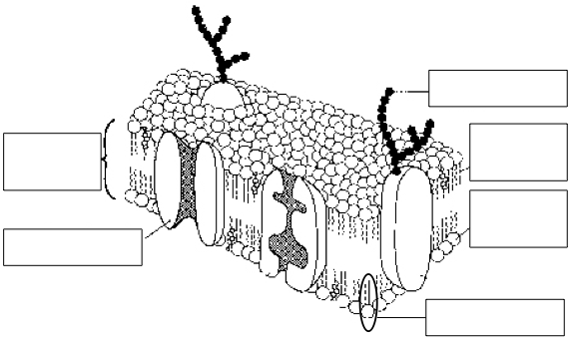

carbohydrate

Nonpolar hydrophobic tail
Lipid bilayer

Polar hydrophilic head
Integral protein

Phospholipid

10. (3 points) A patient receives an IV containing 2.5% (m/v) glucose solution at the rate of 35 mL in 1 hour. How many grams of glucose does this patient receive after 12 hours?

$$12 hours × \frac{35 mL}{1 hour} × \frac{2.5 g Glucose}{100 mL}=10.5 g glucose$$

